Amending a Service Provider on the Simplybook Booking Platform
To support the Covid-19 vaccination delivery
Contents
1 Definition and Purpose 3
2 Considerations before amending 3
2.1 Service Provider Name 3
2.2 Appointment Times 3
2.3 Visibility 3
2.4 Adding New Services Providers 3
3 Adding a new Service Provider 3
3.1 Adding a new Service Provider 3
4 Amending a Service Provider Name 4
4.1 Changing the name of a Service Provider 4
4.2 Amending the Service 4
4.3 Amending the service provider schedule 4
4.4 Setting Special Days 5
5 Deleting a Service Provider 6
5.1 Deleting a Service Provider 6

- Definition and Purpose
This booklet sets out the operational processes for amending a ‘Service Provider’ set up for a clinic. Each clinic has been set with a two ‘Service Provider’ per vaccinator
Should you not be able to find the support you require within this document, please contact the jbs.enquiries@miaa.nhs.uk mailbox, where one of the team will be able to assist.
- Considerations before amending
  - Service Provider Name
The name of the ‘Service Provider’ is not visible on-line to users, and can be renamed to assist with clinical planning. The default is to include the 1st Vaccination and 2nd Vaccination suffix, to easily identify the different capacities.
  - Appointment Times
The default setting for the service is set to 10 minutes. This is to allow 5 minutes for a vaccination, and to accommodate the second appointments. Once appointments have been made, it is not possible to change the timeslots setting. If you would like to set up an extended appointment vaccination lane, then this should be accomplished using a new service.
  - Visibility
In order for users to book the service, the service needs to be visible on the website (open eye symbol). It is important to ensure that the 2nd Vaccination lanes are not visible on the booking website to ensure that sufficient capacity is reserved for the 2nd vaccination events.
  - Adding New Services Providers
Each ‘Service’ need to have ‘Service Providers’ associated to it. When adding a new ‘Service Provider’, be sure to assign it to a ‘Service’. Each vaccinator will need to have two ‘Service Providers’, so set up must be done in duplicate, with one visible and one set to hidden.
- Adding a new Service Provider
  - Adding a new Service Provider
The easiest way of adding a new service is to clone an existing ‘Service Provider’, and amend.
For users with Admin access.
Open your Simplybook account from the admin interface (using a website link).
Select Manage from the sidebar menu, and the ‘Service Provider’
Click on a ‘Service Provider’, and click ‘Clone’
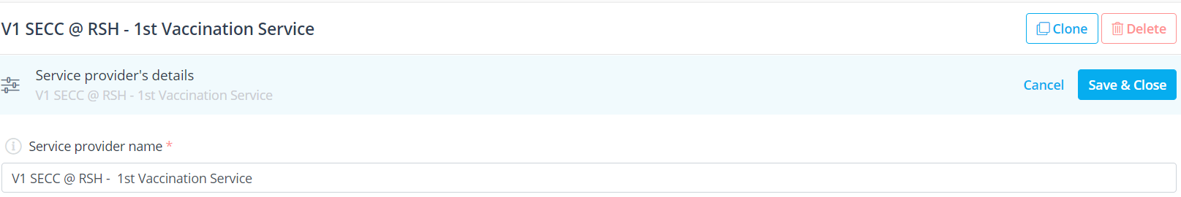
A pop-up will appear ‘Please press OK to confirm cloning’ click ‘Ok’
The clone will now appear on the list on the left hand side, and will share the same name as the Service Provider it was cloned from, and will be prefixed with ‘A Clone’
- Amending a Service Provider Name
  - Changing the name of a Service Provider
For users with Admin access.
Open your Simplybook account from the admin interface (using a website link).
Select Manage from the sidebar menu, and the ‘Service Provider’
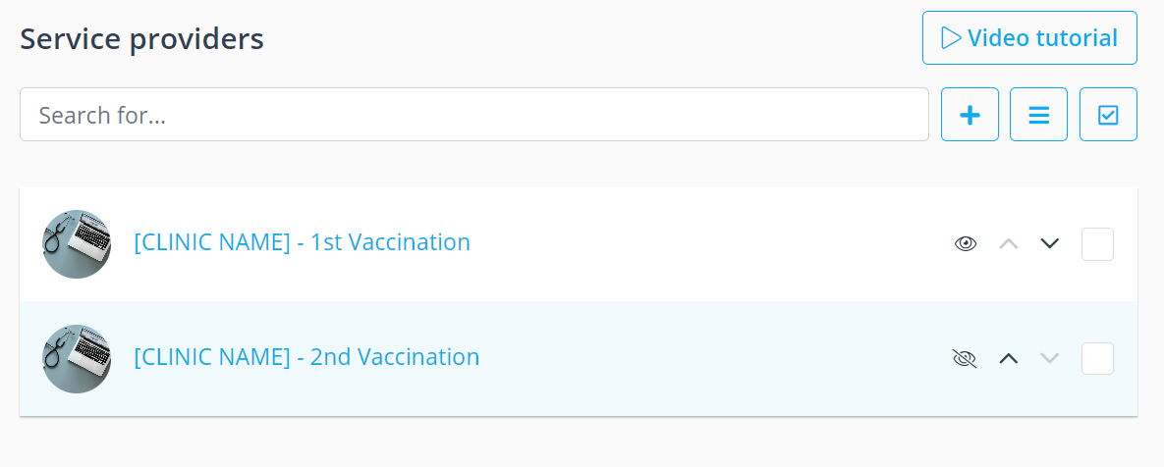
Select the ‘Service Provider’ by clicking on the name
This will bring up the details of the service on the right-hand side.
Click on the ‘service provider name’ field and amend.
Once amended, click ‘Save & Close’.
  - Amending the Service
It is important to ensure that a ‘Service Provider’ is linked to a ‘Service’, and where more than one ‘Service’ exists, the correct one is assigned. And that only one ‘Service’ is selected.
For users with Admin access.
Open your Simplybook account from the admin interface (using a website link).
Select Manage from the sidebar menu, and the ‘Service Provider’
Scroll down to ‘Services, attached to this service provider’
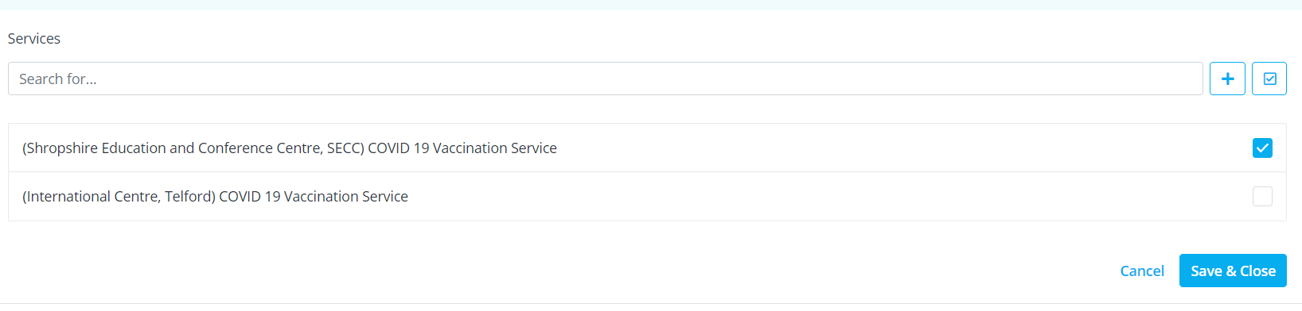
Select the correct ‘Service’, then click ‘Save & Close’

  - Amending the service provider schedule
For each ‘Service Provider’ linked to a vaccinator, any changes to schedule will need to be performed in duplicate to ensure that capacity is evenly spread between the two vaccination calendars
For users with Admin access.
Open your Simplybook account from the admin interface (using a website link).
Select ‘Manage’ from the sidebar menu, and the ‘Service Provider’
Click on the ‘Service Provider’ to be amended, and scroll down to the ‘Service Provider Schedule’
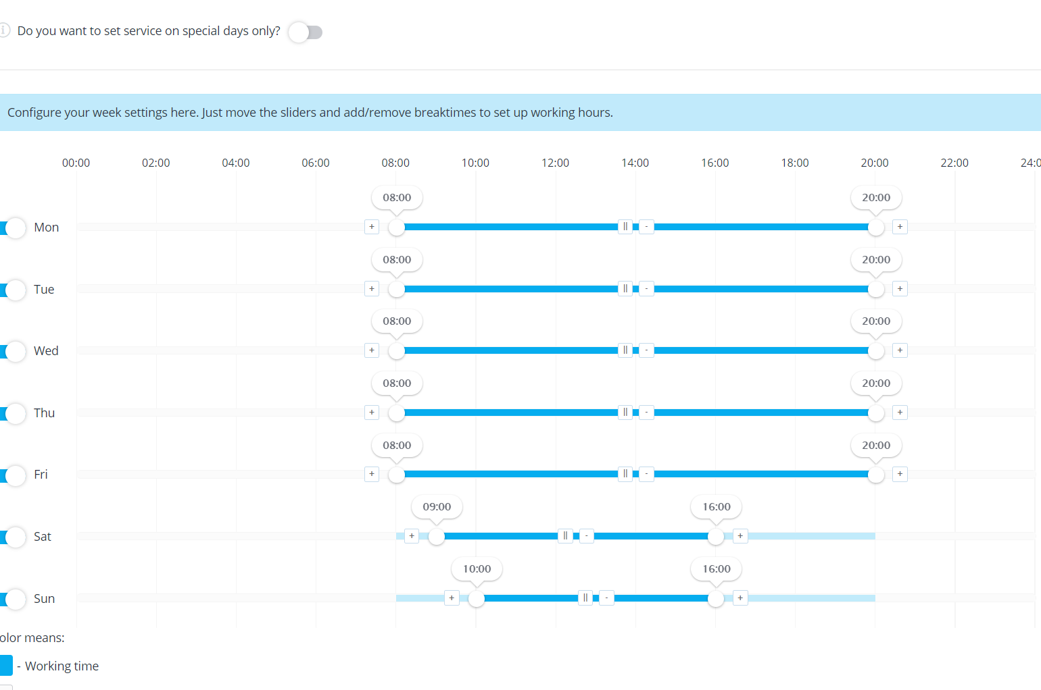
Using the slider, adjust your service opening hours to suit.
To add a break, click on the icon with two vertical lines, and this will separate the slider bar. It should be noted that as appointment booking slots are 10 minutes long, breaks need to be set at 00,10,20,30,40,50 minutes past the hour
Once you have finished editing, click ‘Save & Close’
This will need to be replicated on the linked ‘Service Provider’ calendar.
  - Setting Special Days
In instances where you need to set a special day, for example such as annual leave (where no cover exists), this should be accomplished using the Special Days function. For changes to the clinics operational hours, this should be done at ‘company’ level, if there is more than one service.
For users with POS access and above.
Open your Simplybook account from the admin interface (using a website link).
Select ‘Time Settings’ from the sidebar menu, and then ‘Providers Provider Schedule’, and then ‘Special Days Schedule’
Select the date on the calendar and pop-up will appear to allow you to make changes
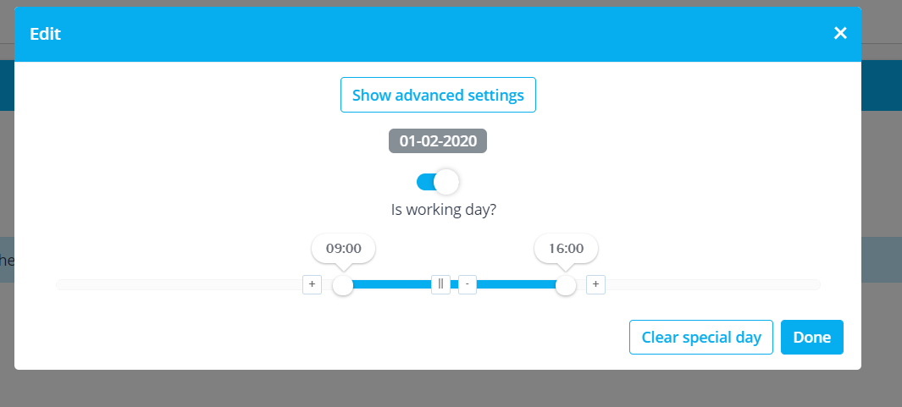
When you have finished editing, click ‘Done’
The date amended now appears highlighted yellow on the calendar.
This will need to be replicated on the linked ‘Service Provider’ calendar.
- Deleting a Service Provider
If a ‘Service Provider’ has been created in error, it can be deleted, provided no bookings have been associated with it. Where bookings have been made, the ‘Service Provider’ should be hidden instead, by changing the visibility
  - Deleting a Service Provider
For users with Admin access.
Open your Simplybook account from the admin interface (using a website link).
Select ‘Manage’ from the sidebar menu, and the ‘Service Provider’
Select the ‘Service Provider’ to be deleted, by checking the box
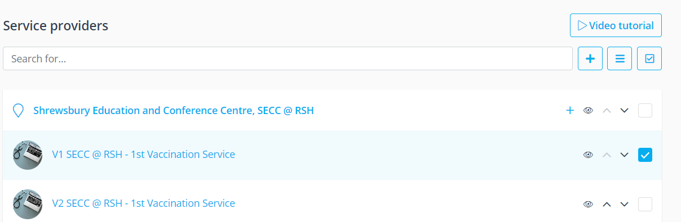
Click the three line menu icon, and select ‘delete’
A pop-up box will ask ‘Are you sure you want to delete selected elements?’, click ‘OK’
This will need to be replicated on the linked ‘Service Provider’ calendar.

